Tactical report for emotet malware

Identification
Vendor | Detection
TrendMicro | Trojan.W97M.EMOTET.AFKW
Microsoft | TrojanDownloader:O97M/Emotet.OA!MTB
Ikarus | Trojan-Downloader.VBA.Emotet

The following table contains a list of artifacts that had been analyzed within this document.
PE timestamp | MD5 | Size in bytes | File name | Description
2019-10-11 Sat12:46:00 UTC | 0643324FA7F74A3C5288CDE9D26C19A8 | 281.5 KB (288256 bytes) | Index.html | downloader

Summary
Emotet was originally designed as a banking malware that attempted to sneak onto your computer and steal sensitive and private information .The infection may arrive either via malicious script, macro-enabled document files, or malicious link. Emotet emails may contain familiar branding designed to look like a legitimate email. Emotet also uses C&C servers to receive updates and install updated versions of the software, install additional malware such as other banking Trojans, or to act as a dumping ground for stolen information such as financial credentials, usernames and passwords, and email addresses.

Technical analysis of malicious word
As shown in figure (0) this is the first view of emotet so once we open word and enable micro then it execute malicious micro code.
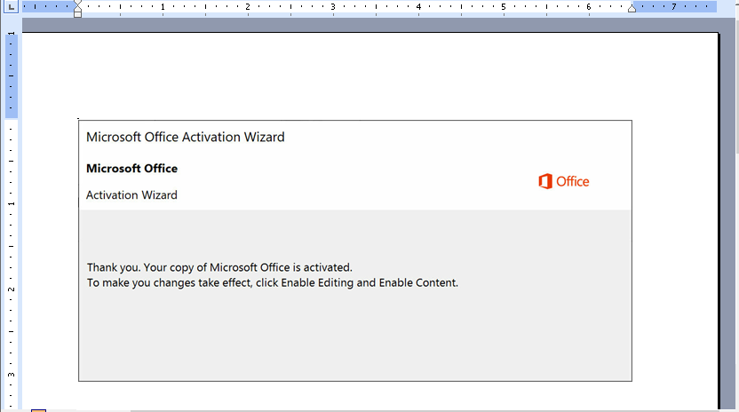Figure (0)
As shown in figure (1), (2) the obfuscation is malware is high. It makes some calculation to connect to specific urls.
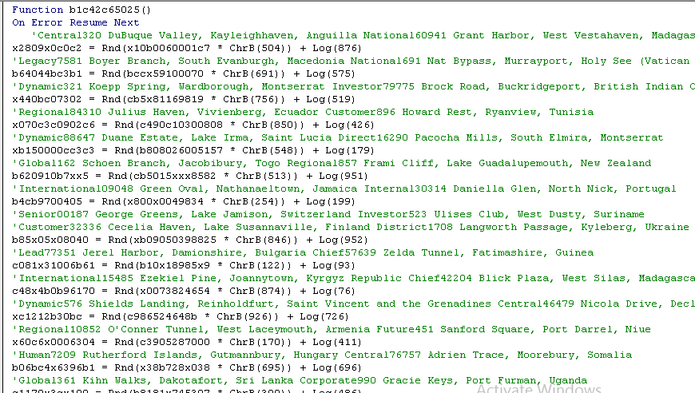
Figure (1)
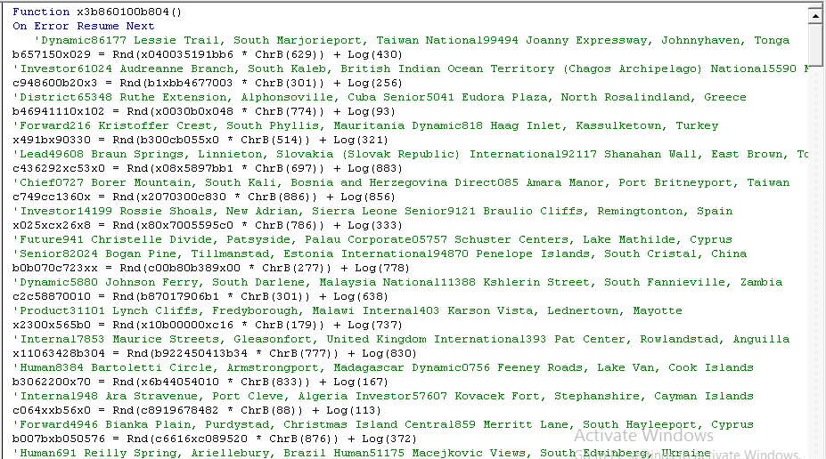
Figure (2)
Command and control server
It opens PowerShell and executes command as shown in figure (3) with is encodes with base64.
Figure (3)
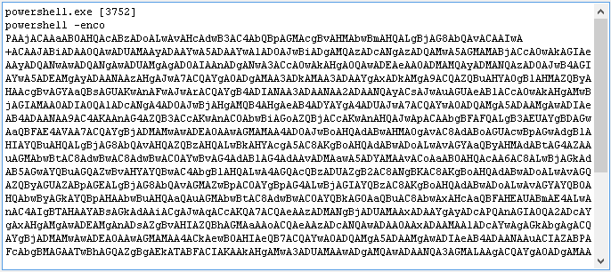
Figure (3)

After decoding it using base64 the result will be embedded urls as shown in figure (4).
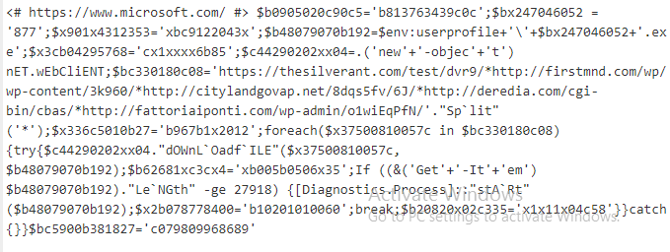
Figure (4)
Then after handling it and extracting urls we get result as shown in figure (5).
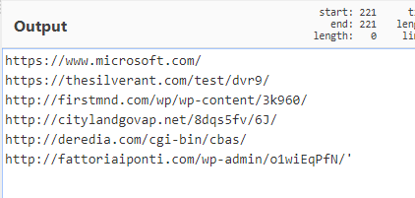
Figure (5)
So emotet connects to these domains and gets executable file.

Domains
- https://thesilverant[.]com/test/dvr9/.
- http://firstmnd[.]com/wp/wp-content/3k960/.
- http://citylandgovap[.]net/8dqs5fv/6J/.
- http://deredia[.]com/cgi-bin/cbas/.
- http://fattoriaiponti[.]com/wp-admin/o1wiEqPfN/.

HTTP Requests
These are full http request of each domain as shown in figure (6), (7), and (8).
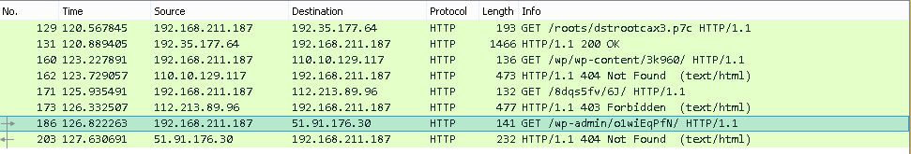
Figure (6)
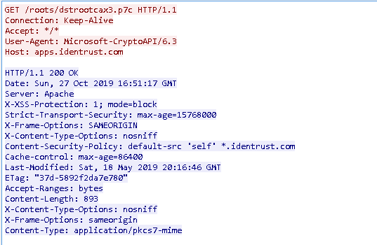
Figure (7)
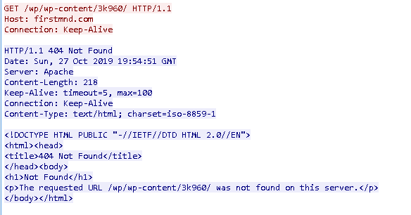
Figure (8)
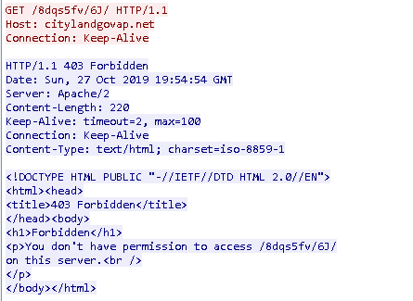
Figure (9)
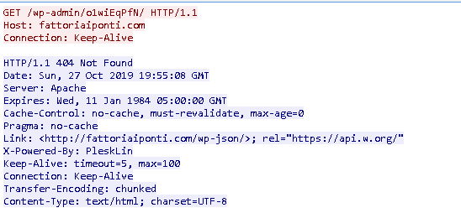
Figure (10)
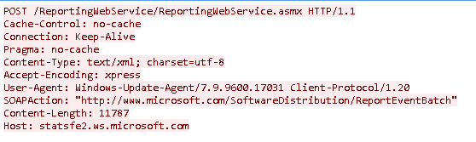
Figure (11)
It drops file called 3k960.exe as shown in figure (8). This file is executable file, so let’s see purpose of it.
When we execute file 3k960.exe, it drops file called reswnop.exe in path C:\Users\UserName\AppData\Local\reswnop then creates new process called reswnop.exe and finally deletes 3k960.exe file as shown in figure (12), (13), and (14).
Figure (12)
Figure (13)
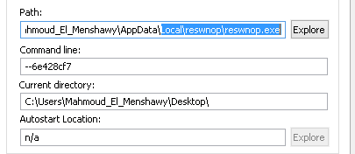
Figure (14)
So let’s see purpose of file reswnop.exe.

PE timestamp | MD5 | Size in bytes | File name | Description
2019-9-30  Mon 18:18:17 UTC | D09A466039FFE16E231A202BD6259DB8 | 57.5 KB (58,880 bytes) | reswnop.exe | Infection +downloader

Technical analysis
Obfuscation
The import address table and strings of emotet is already encrypted inside the code as shown in figure (15) so that’s mean it will resolve during run time in specified functions.

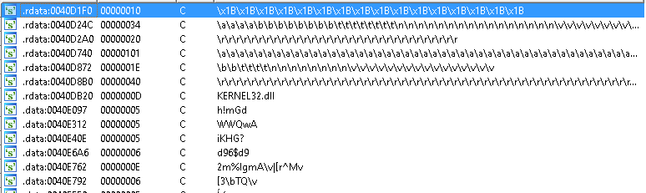
Figure (15)
So for simplification, it resolves Apies using hash value then assign every hash value to global variable and finally call the global variable. The 2 subroutine below are responsible for resolve Apies and strings not all of them as shown in figure (16).
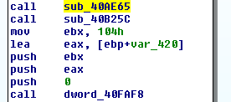
Figure (16)
Persistence
It resolves string called --8c4f2ffd as command line to create new process with current executable of filename as shown in figure (17), (18).

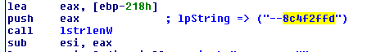
Figure (17)
Figure (18)
If process already created with the following parameter then it continues execution of malware.
It gets serial number of volume then it creates 2 new mutex and event as shown in figure (19), (20), and (21).
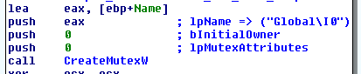
Figure (19)
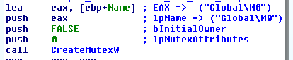
Figure (20)
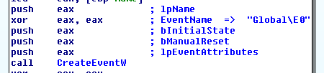
Figure (21)
It checks for debugger is present or not if yes or if it couldn’t create mutex then it will terminate as shown in figure (22).
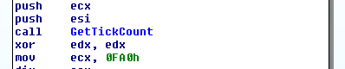
Figure (22)
The main functionality of malware is divided into 4 switch cases based on global variable.

Default case
It resolves apis of library called advapi32.dll as shown in figure (23).
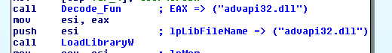
Figure (23)
It resolves apis of library called shell32.dll as shown in figure (24)
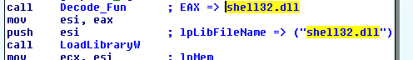
Figure (24)
It gets computer name and add 8 numbers to it as shown in figure (25).
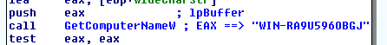
Figure (25)
It deletes file called chunkbased.exe in system windows directory as shown in figure (26).
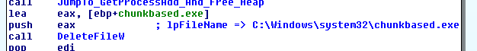
Figure (26)
It deletes zone identifier of malware running file to prevent tracing as shown in figure (27).
Figure (27)
It creates service called reswnop as shown in figure (28) with the following parameters as shown in table and starts it.
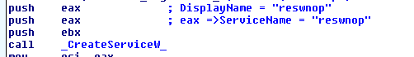
Figure (28)

Parameter | Value
ServiceName | reswnop <current file name>
DisplayName | reswnop
DesiredAccess | SERVICE_CHANGE_CONFIG|SERVICE_START
ServiceType | SERVICE_WIN32_OWN_PROCESS
StartType | SERVICE_AUTO_START
ErrorControl | SERVICE_ERROR_IGNORE

It changes value of global variable to 1 to change to another execution.
It checks for debugger is present or not using timing technique as shown in figure (29).
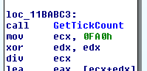
Figure (29)
Case (1)
It resolves apis of libraries called crypt32.dll, urlmon.dll, userenv.dll, wininet.dll, wtsapi32_dll as shown in figure (30 to 34)

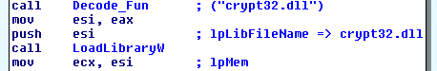
Figure (30)
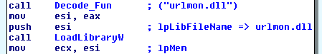
Figure (31)
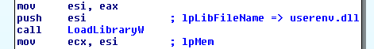
Figure (32)
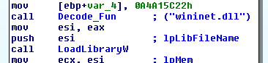
Figure (33)
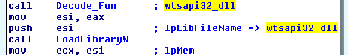
Figure (34)
It list windows crypto apis and generate new key as shown in figure (35), maybe this key used for decryption downloaded thing.
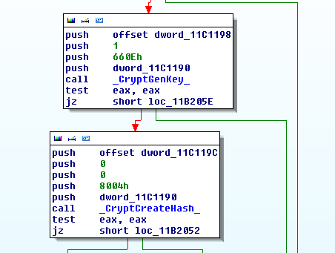
Figure (35)
It moves (computer name + <8 number of serial volume>) to global variable.
It sets global variable to 2 to navigate to case 2 as shown in figure (36).
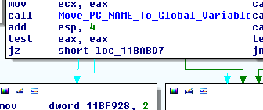
Figure (36)

Case 2
It gets pc_name,RtlGetVersion, GetNativeSystemInfo as shown in figure (37) and other information as shown in figure (38) preparing them to send to attacker server.
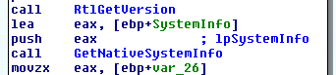
Figure (37)

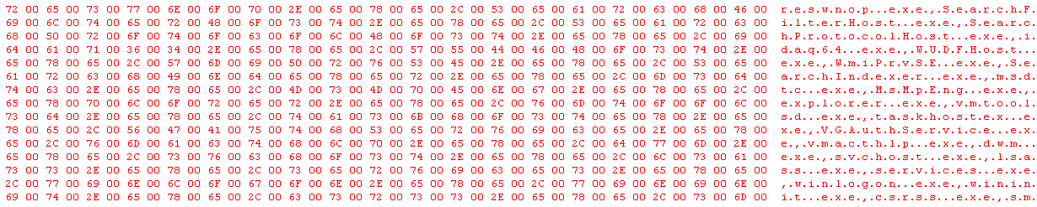
Figure (38)

Command and control server
It decodes ip address and prints it as shown in figure (39).
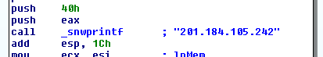
Figure (40)
It decodes string as to use them for post url as shown in figure (41), (42).
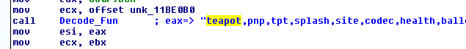
Figure (41)

Figure (42)
It decodes full url request as shown in figure (43).
Figure (43)
Full url
- "Referer: http://<ip>/cookies/devices/prep/merge/Content-Type: application/x-www-form-ur”

It generates long string as shown in figure (44).
Figure (44)

It gets user agent and connect to internet as shown in figure (45).
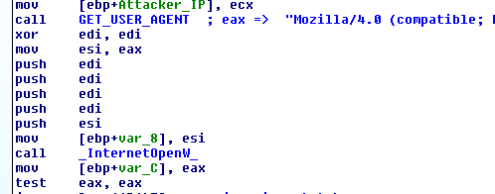
Figure (45)
User-Agent
- "Mozilla/4.0 (compatible; MSIE 7.0; Windows NT 6.2; Trident/7.0; .NET4.0E; .NET4.0C; .NET CLR 3.5.307".
It connects to attacker ip as shown in figure (46).
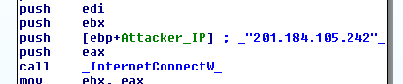
Figure (47)
Port : 443

Post request
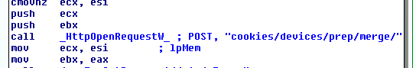
Figure (48)
Then download file but the usual thing is that emotet tries to connects to large number of ip and install another malware files for more persistence as shown in figure (49)
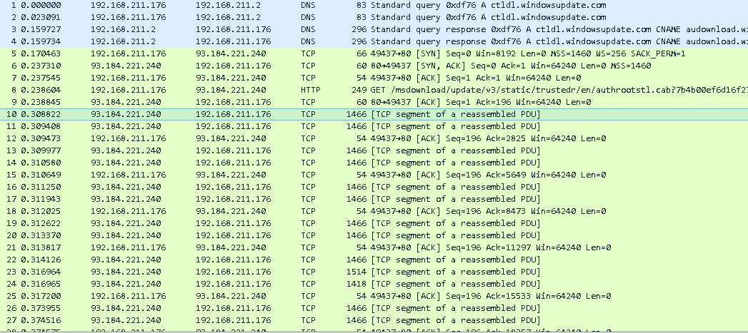
Figure (49)
He is some list of ip address that emotet connects to them
- 93.184.221.240
- 23.50.187.167
- 204.79.197.203
- 213.158.179.25
- 151.101.241.108
- 93.184.220.29
- 172.217.18.227
- 52.142.114.2
- 204.79.197.200
- 151.193.128.14
- 213.158.179.25
- 104.18.25.243
- 37.252.172.100
- 107.23.115.104
- 172.217.19.34
- 37.252.172.250
- 151.101.241.108
- 172.217.18.227
- 23.57.84.236
- 23.57.85.127
- 185.63.144.5
- 151.101.242.2
- 52.77.178.234
- 40.90.23.208
- 37.252.172.250
- 104.18.21.226
- 23.50.156.242
- 23.50.156.242
- 151.139.128.14
- 52.85.22.70
- 204.13.202.71
- 204.79.197.200
- 182.50.136.239
- 37.252.172.250
- 212.82.100.176
- 192.35.177.64
- 52.85.22.74
- 79.140.95.97
- 52.85.22.138
- 213.158.179.161
- 2.19.27.190
- 2.20.231.146

It creates another registry key for persistence in infected machine as shown in figure (50) with the following parameters as shown in table.
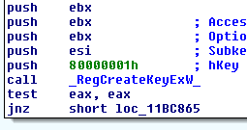
Figure (50)

ValueName | reswnop < current malware name >
hKey | HKEY_CURRENT_USER
Subkey | SOFTWARE\Microsoft\Windows\CurrentVersion\Run
Options | REG_OPTION_NON_VOLATILE
Access | KEY_SET_VALUE

Case 3
It terminates process with set new event then exit as shown in figure.
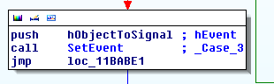
Figure (50)
References
- https://www.nirsoft.net/utils/mailpv.html..
- https://www.us-cert.gov/ncas/alerts/TA18-201A..
- http://www.cse.yorku.ca/~oz/hash.html.

